**FREQUENCY SYNTHESIZER BOX PINOUT**

Frequency Synthesizer Block

Frequency Synthesizer Block

Frequency Synthesizer Block

REF-OUT

REF-EX

RF -

RF +

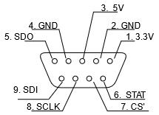

REF-OUT

REF-EX

RF -

RF +



REF-OUT

REF-EX

RF -

RF +

